1. Create a repository

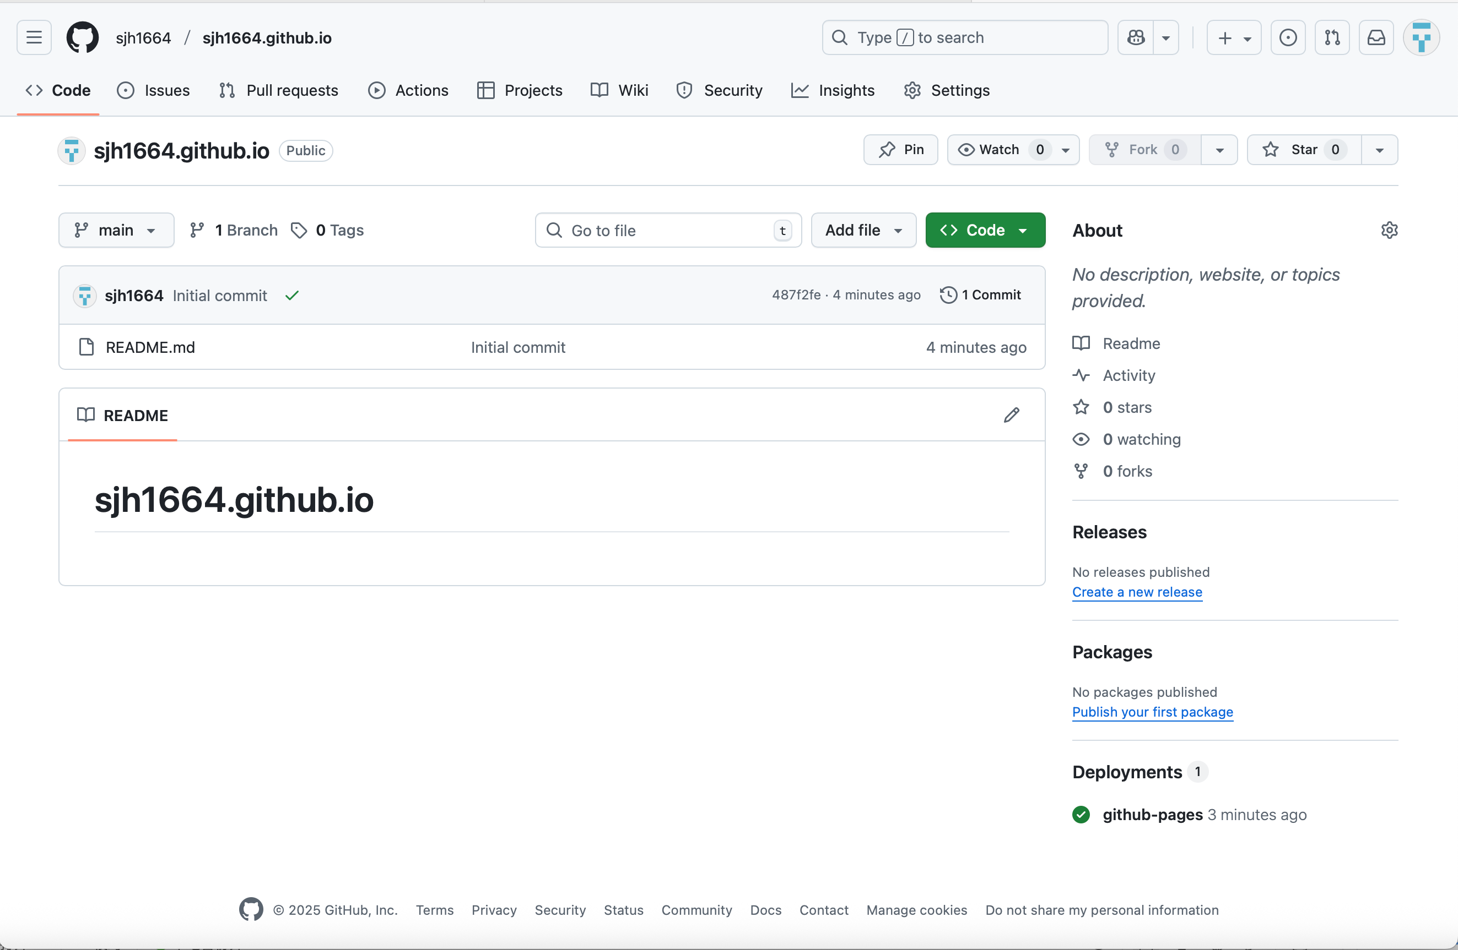

1. Clone the repository to the local machine

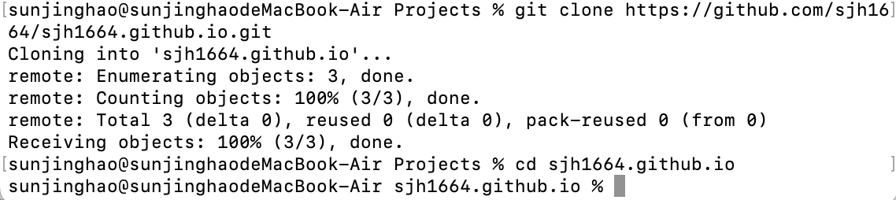

1. Create the home page file

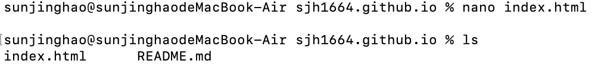

1. Submit and push to GitHub

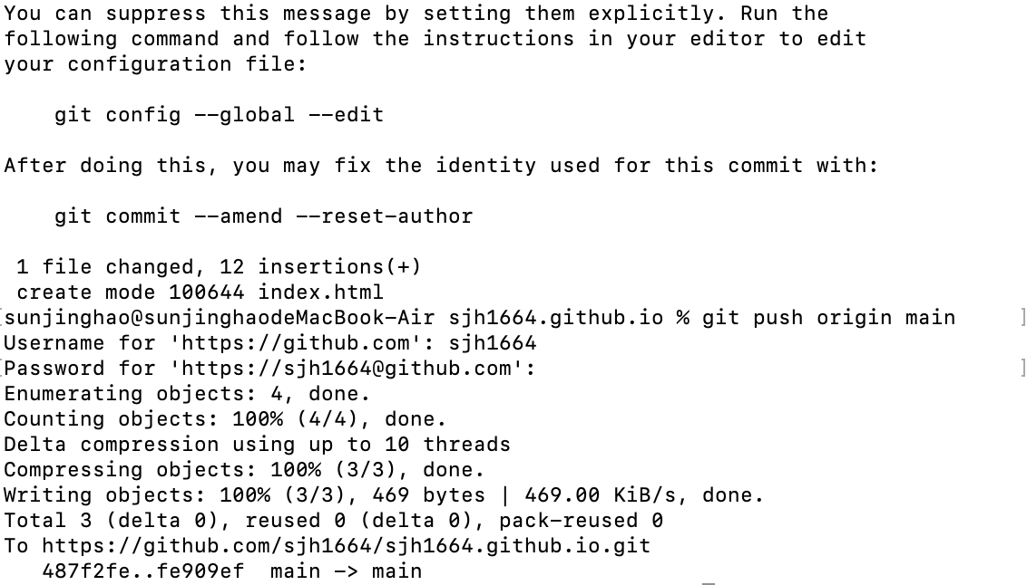

1. Visit my personal website

